New iPhone App LinkMeUp Lets You Painlessly Send Any YouTube Video To A Friend

Seattle, WA July 9, 2015

Sending music and videos to your friends just got a lot easier. The new [iPhone app LinkMeUp](https://itunes.apple.com/us/app/id916400771?mt=8) lets you search for and send YouTube videos to anyone in your phone’s contact list – without having to open up a browser, or copy and paste any URLs.

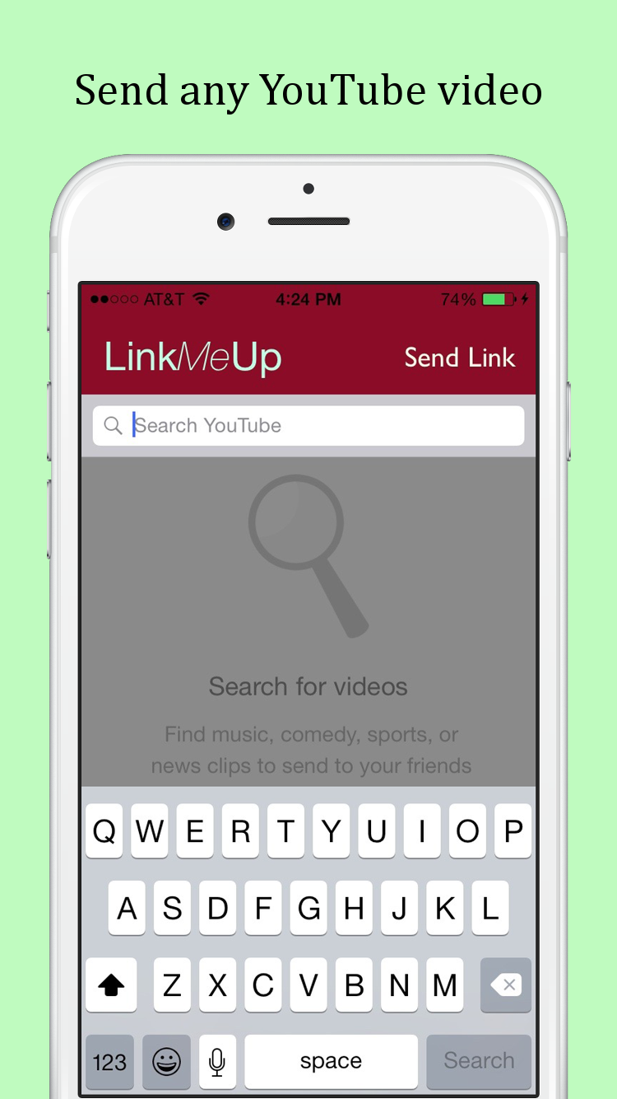 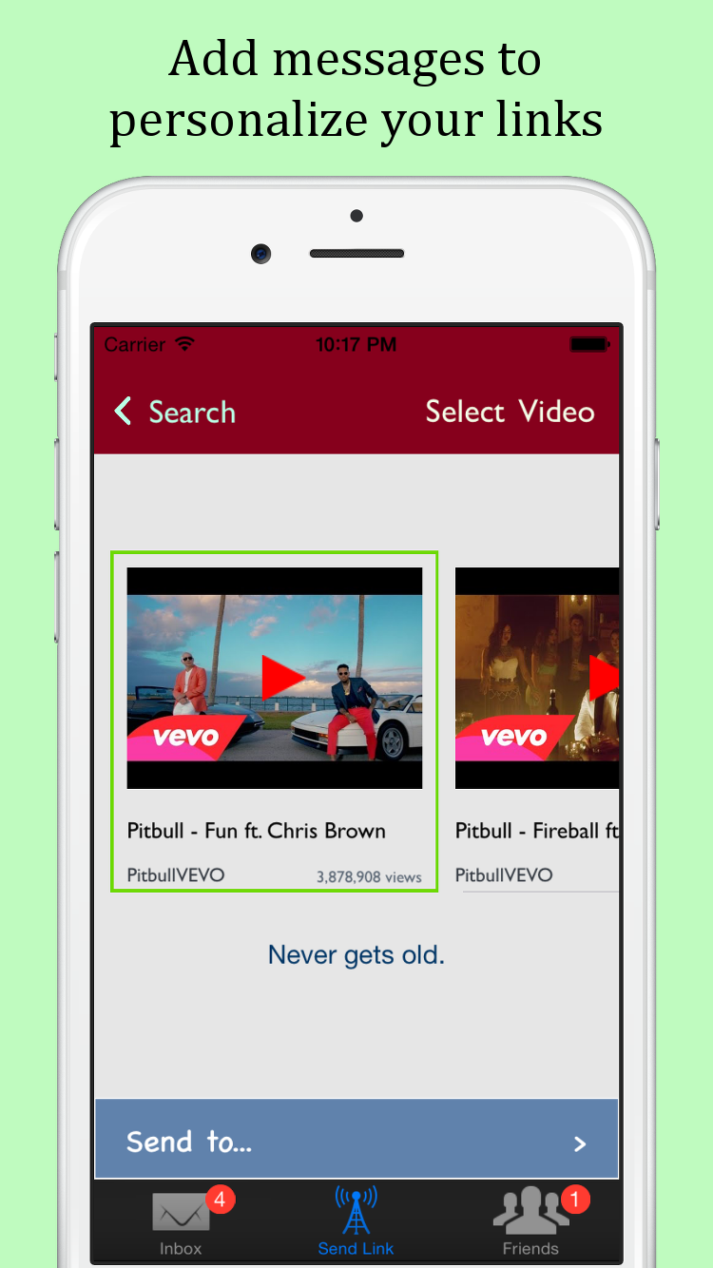 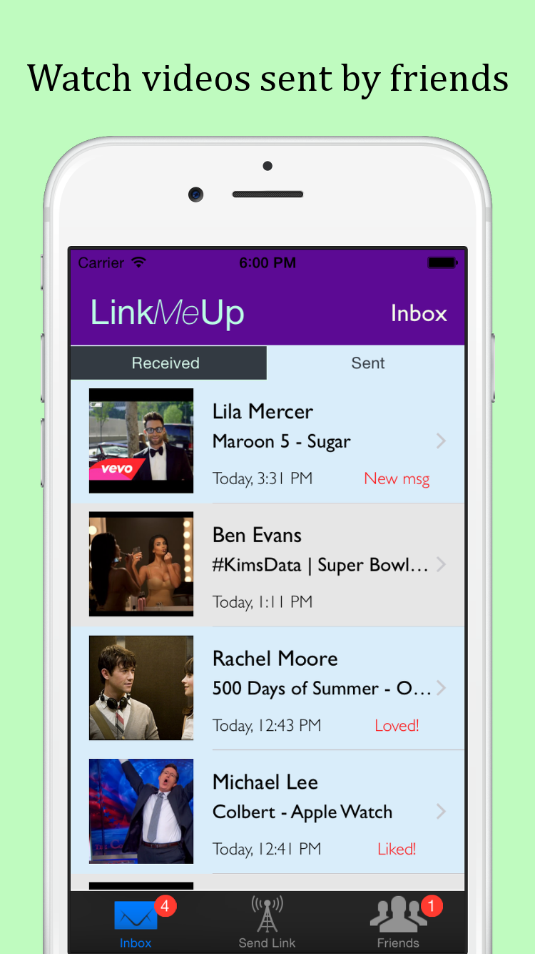

According to LinkMeUp founder and CEO, Samvit Jain, Facebook and email don’t quite cut it when it comes to sharing links with close friends. “Facebook is optimized for sharing with a large network, not sending a personalized recommendation to a few friends. Email is quick, but it’s drab and a bit too formal for any follow-up conversation.”

But what about the whole slew of messaging apps that have taken root in the last few years – Facebook Messenger, GroupMe, WhatsApp – and even Apple’s default Messages app? “Messaging apps are great for user-generated content – text, photos, video,” says Jain, “but they aren’t designed for linking to media on the web.” For one thing, finding a URL usually requires exiting the app. But more fundamentally, a link, in a conventional messaging app, is just another message, easily lost in a long thread – not a standalone snapshot that can be forwarded to another friend, or saved and viewed again later.

These are precisely the capabilities that LinkMeUp introduces. They call their new concept “link messaging,” continuing the latest trend of specialized, social apps that focus on doing one thing really well. For early Snapchat, that one thing was photo sharing – the company even filed a patent for the “tap and hold” feature that allows users to take a picture or video by either tapping or holding the camera button[1], a seemingly trivial innovation that in fact made rapid, real-time “photo conversation” truly viable. Could LinkMeUp’s “three steps to sent” – search for a video, add a message, and choose recipients – similarly make link messaging a phenomenon?

The Seattle, Washington-based startup does have one big advantage. The app neatly taps into two immense, existing user bases – that of YouTube, a service that counts over a billion users and is available in 61 languages[2], and that of internet-connected mobile devices. Two billion smartphone users in 2014, a number that is projected to double by 2020 and thus include 80% of adults worldwide[3], means 2 billion people watching cat videos – not on desktop PCs, where sharing those cat videos is easy, but on fragmented, *mini*-computers, where, until now, users have had to use separate apps for watching those videos and for chatting with friends. It is this growing space that LinkMeUp hopes to enter.

The app, which was in private beta until this summer, launched to the public in the App Store today. LinkMeUp for Android, according to Jain, is scheduled for release in mid-August.

###

For more information about LinkMeUp, visit [www.linkmeupmessenger.com](http://www.linkmeupmessenger.com) or email LinkMeUp at contact AT linkmeupmessenger.com.

1. Gallagher, Billy, “Snapchat Has A Patent That Could Help It Become The Defacto Camera App,” TechCrunch, June 21, 2013.
2. “Statistics,” Youtube – Press, 2015.
3. Evans, Benedict, “Mobile is Eating the World,” Andressen Horowitz, Oct. 28, 2014.